

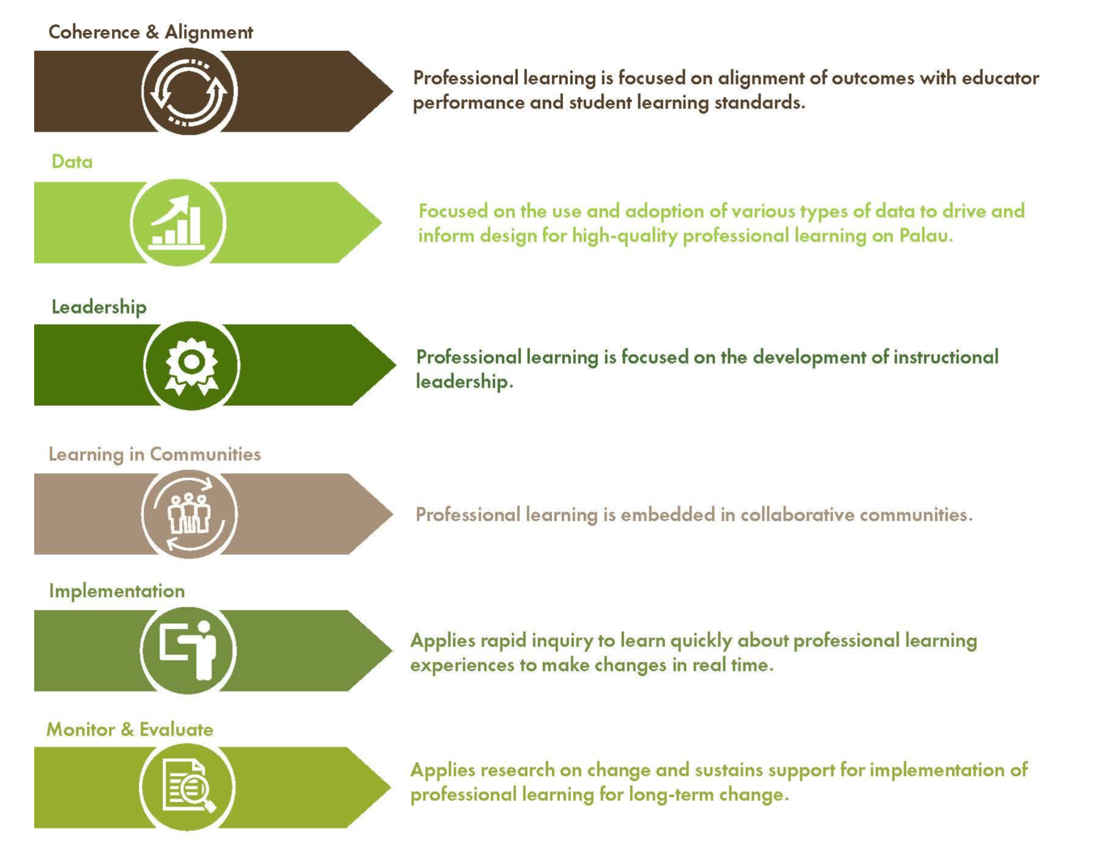

**Instructional Coaching**

Connects teacher expectations and actions with student learning standards and outcomes

Uses teacher and student data to inform reflection and planning

Develops principal and specialist leadership skills

Fosters job-embedded, collaborative learning

Includes weekly debrief opportunities to check in, clarify and celebrate progress

Developing internal capacities to self-train after the grant has ended